* **Signals & Systems:**

**\* Lab :1**

**\*Section: 8**

|  |  |
| --- | --- |
| **Name** | **ID** |
| **مهاب حسن محمد حسن** | **18011883** |
| **محمد عبد السلام عبدالمطلب** | **18011535** |

%Q(1)

S = [ 150 150 150 160 ];

s2005=S+10

S2006=(s2005)+(s2005)*0.1

%----------------------------------------------------

%Q(2)

V=[2 8 7 3 1 0 8 9];

V(mod(V,2)~=0)=1

V(mod(V,2)==0)=-1

%----------------------------------------------------

%Q(3)

V=[ 1;2;3;4;5;6;7;8;9;10];

%(a)Add 2 to the last 3 elements of V

V(end:-1:end-2)+2

%(b) )Reverse the order of the last 4 elements of V

V(end:-1:end-3)

%(c)) Add the elements number 1, 3, 5 …etc to the elements number 2, 4, 6

for i=1:2:10

V(i+1)=V(i)+V(i+1)

end

%----------------------------------------------------

%Q(4) Write down a single Matlab instruction that generates the following sequence: 1 4 9 16 …

[(1:9).^2 (8:-1:1).^2 ]

%----------------------------------------------------

%Q(5)

M=[ 1 2 3 4; -1 -2 -3 -4 ;1 2 3 4 ;-1 -2 -3 -4 ];

% a) Reflect array (M) left-side right,

M( :,[end,end-1,end-2,end-3] )

% b) Reflect array (M) upside down

M([end,end-1,end-2,end-3],: )

% c) Swap columns 2 and 3 of array (M),

M( :,[end-3,end-1,end-2,end] )

% d) Swap rows 1 and 4 of array (M),

M( [end,end-2,end-1,end-3],: )

% e)Shuffle the rows of(M)from [1 2 3 4] to [1 3 4 2] and shuffle the columns of

M([1,2,3,4],:)=M([1,3,4,2],:)

M(:,[1,2,3,4])=M(:,[3,2,4,1])

%----------------------------------------------------

%(6)

x=[ 1 0 0 0 -1 ; 2 0 0 0 -2 ; 3 0 0 0 -3 ;4 0 0 0 -4;5 0 0 0 -5]

y=x'

z=y;

z(:,[end end-1])=z(:,[end-4 end-3])

w=x;

w(:,end)=w(:,end-4)*0.1;

w(:,end-4)=w(:,end-4)*2;

for i=6:20

if w(i)==0

w(i)=100;

else

w(i)=w(i);

end

end

w

%--------------------------------------------------

%Q(7)

A=zeros(5,5);

B=zeros(5,1);

A=[ 2 3 5 6 21 ;5 0 2 2 0;6 7 8 9 11;0 13 17 5 6;1 4 0 3 9];

B=[ 152;19;135;127;66];;

C= [ A B ];

rank(A)==rank(C)

rank(A)==5

rank(A)==length(A)

D=(A^-1)*B

**Q(7)**

((a))

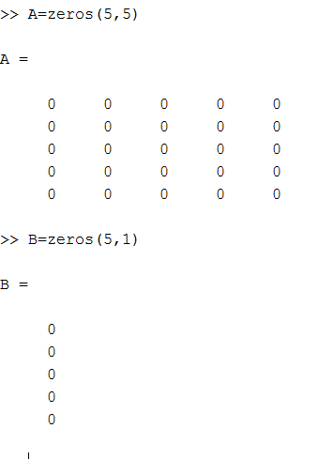

((b))

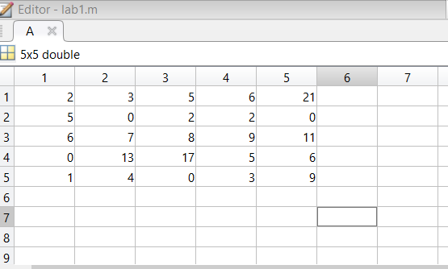

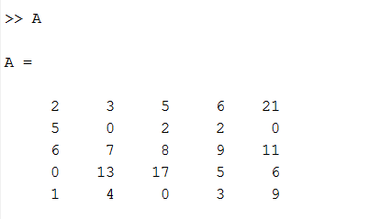

**(( c ))**

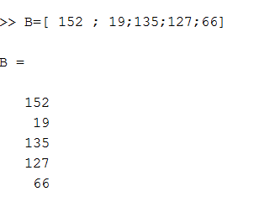

**((d))**

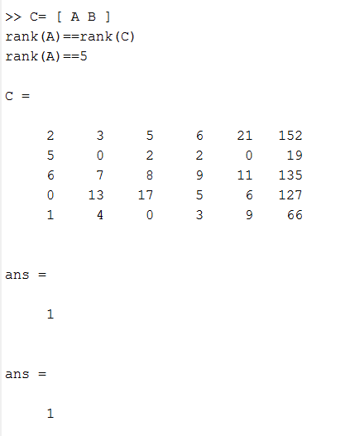

**(( e ))**

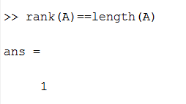

**((f))**

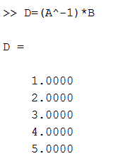

**\*Matlab Help System:**

**(a)**

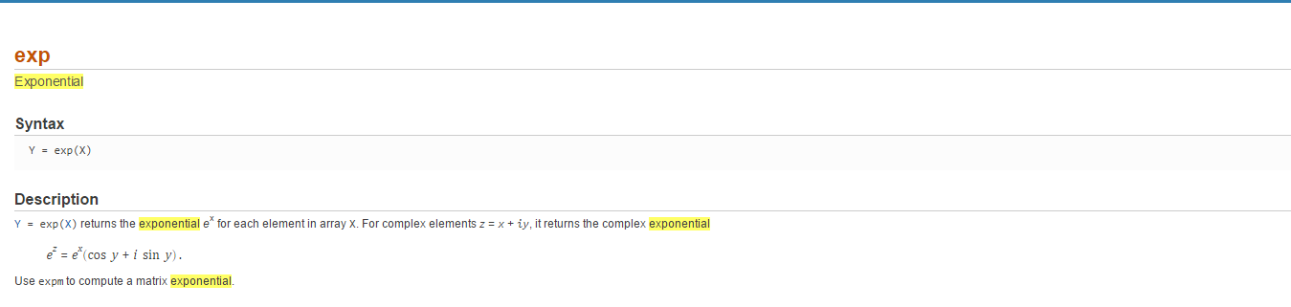

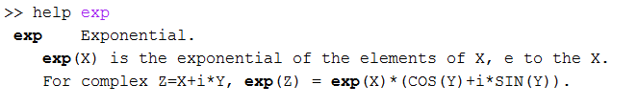

**(b)**

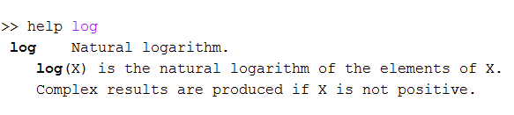

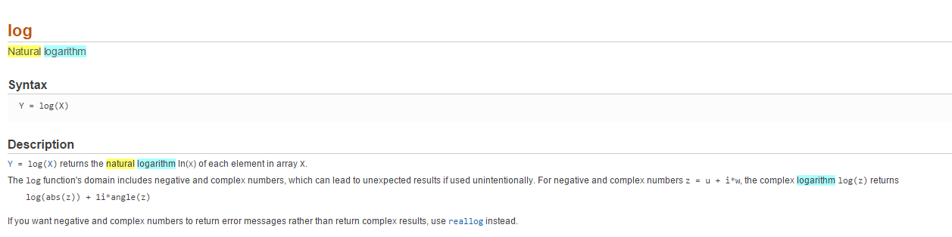

**( c )**

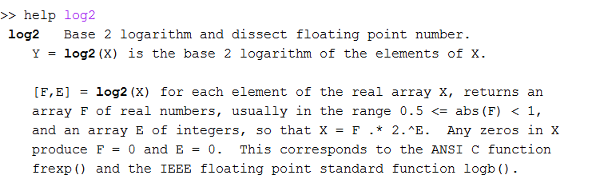

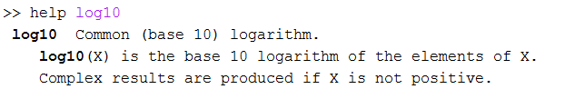

**(d)**

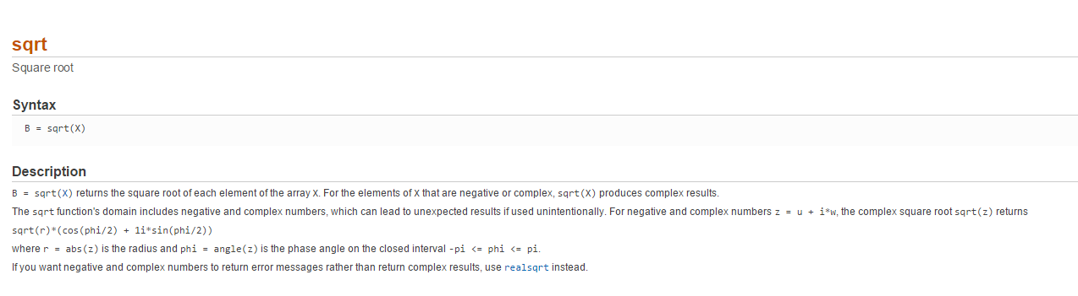

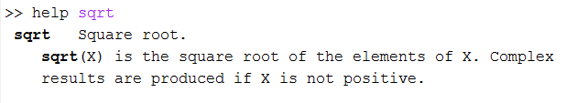

**(e)**

